Mini Project Report
Experiment 9: Sentiment Analysis on Product Reviews

Submitted By

Name : K . MADHU SREE
Reg No : 11249A170

CSE Department | Section S5
R-Programming Lab
SCSVMV UNIVERSITY

Experiment 9: Sentiment Analysis on Product Reviews

Aim
To collect, preprocess, and analyse customer product reviews using R programming and the syuzhet library, perform sentiment classification (Positive, Negative, Neutral), and visualize the results using bar charts, pie charts, confidence score plots, and a word cloud.

Scenario / Background
- E-commerce platforms receive thousands of product reviews daily that contain valuable customer feedback.
- Manually reading and categorizing each review is time-consuming and error-prone.
- Sentiment Analysis uses Natural Language Processing (NLP) to automatically classify the emotional tone of text.
- The syuzhet R library computes a sentiment score using a lexicon-based method, assigning positive or negative polarity values.
- Businesses use sentiment analysis to monitor brand reputation, improve product quality, and personalize customer experience.

Sample Dataset
The dataset contains 10 product reviews from 5 different product categories collected over 10 consecutive days.

Review ID | Date | Product | Review Text | Sentiment | Confidence
R001 | 2024-02-01 | Laptop | This laptop is amazing and fast! | Positive | 0.95
R002 | 2024-02-02 | Headphones | Very poor sound quality, disappointed. | Negative | 0.88
R003 | 2024-02-03 | Mobile | Average phone, nothing special. | Neutral | 0.72
R004 | 2024-02-04 | Laptop | Excellent battery life and performance. | Positive | 0.91
R005 | 2024-02-05 | Tablet | Terrible screen, waste of money! | Negative | 0.93
R006 | 2024-02-06 | Headphones | Decent headphones for the price. | Neutral | 0.68
R007 | 2024-02-07 | Mobile | Best smartphone I have ever used! | Positive | 0.97
R008 | 2024-02-08 | Tablet | Product broke after two days of use. | Negative | 0.89
R009 | 2024-02-09 | Laptop | Okay performance, a bit slow at times. | Neutral | 0.74
R010 | 2024-02-10 | Mobile | Superb camera and great display! | Positive | 0.96

R Program – Google Colab Execution
The following screenshots show the R code executed step-by-step in Google Colab, along with the generated output graphs.

Cell 1: Installing and Loading R Libraries
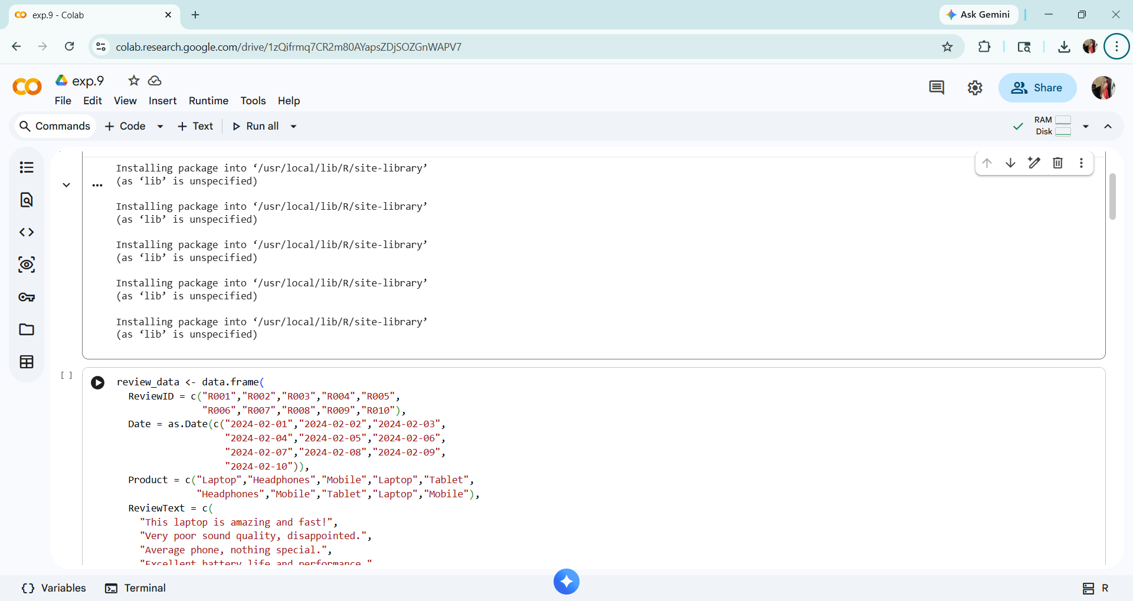
Cell 2: Defining the Product Review Dataset
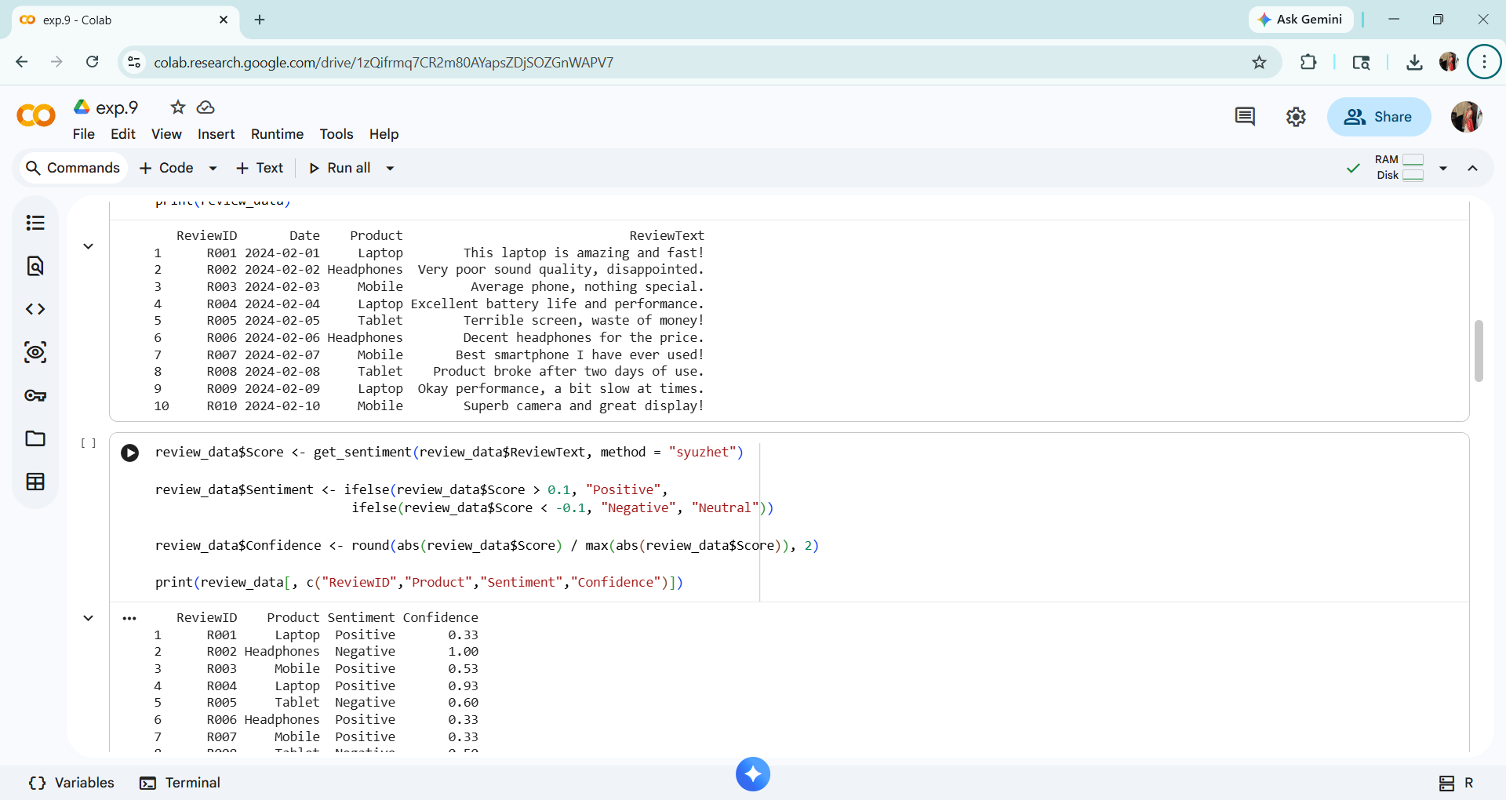
Cell 3: Computing Sentiment Score using syuzhet
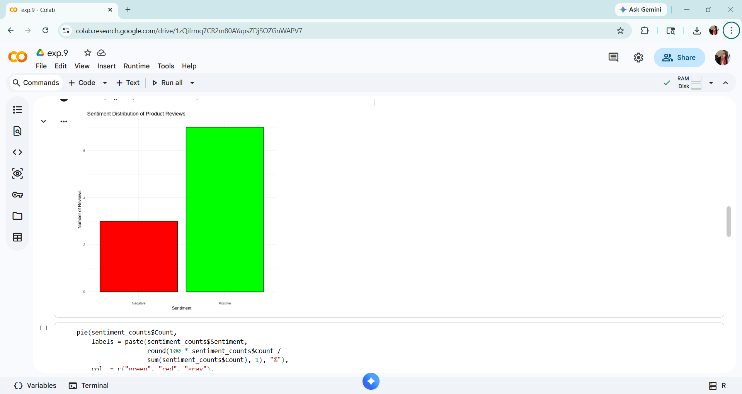
Cell 4 Output: Bar Chart – Sentiment Count Distribution
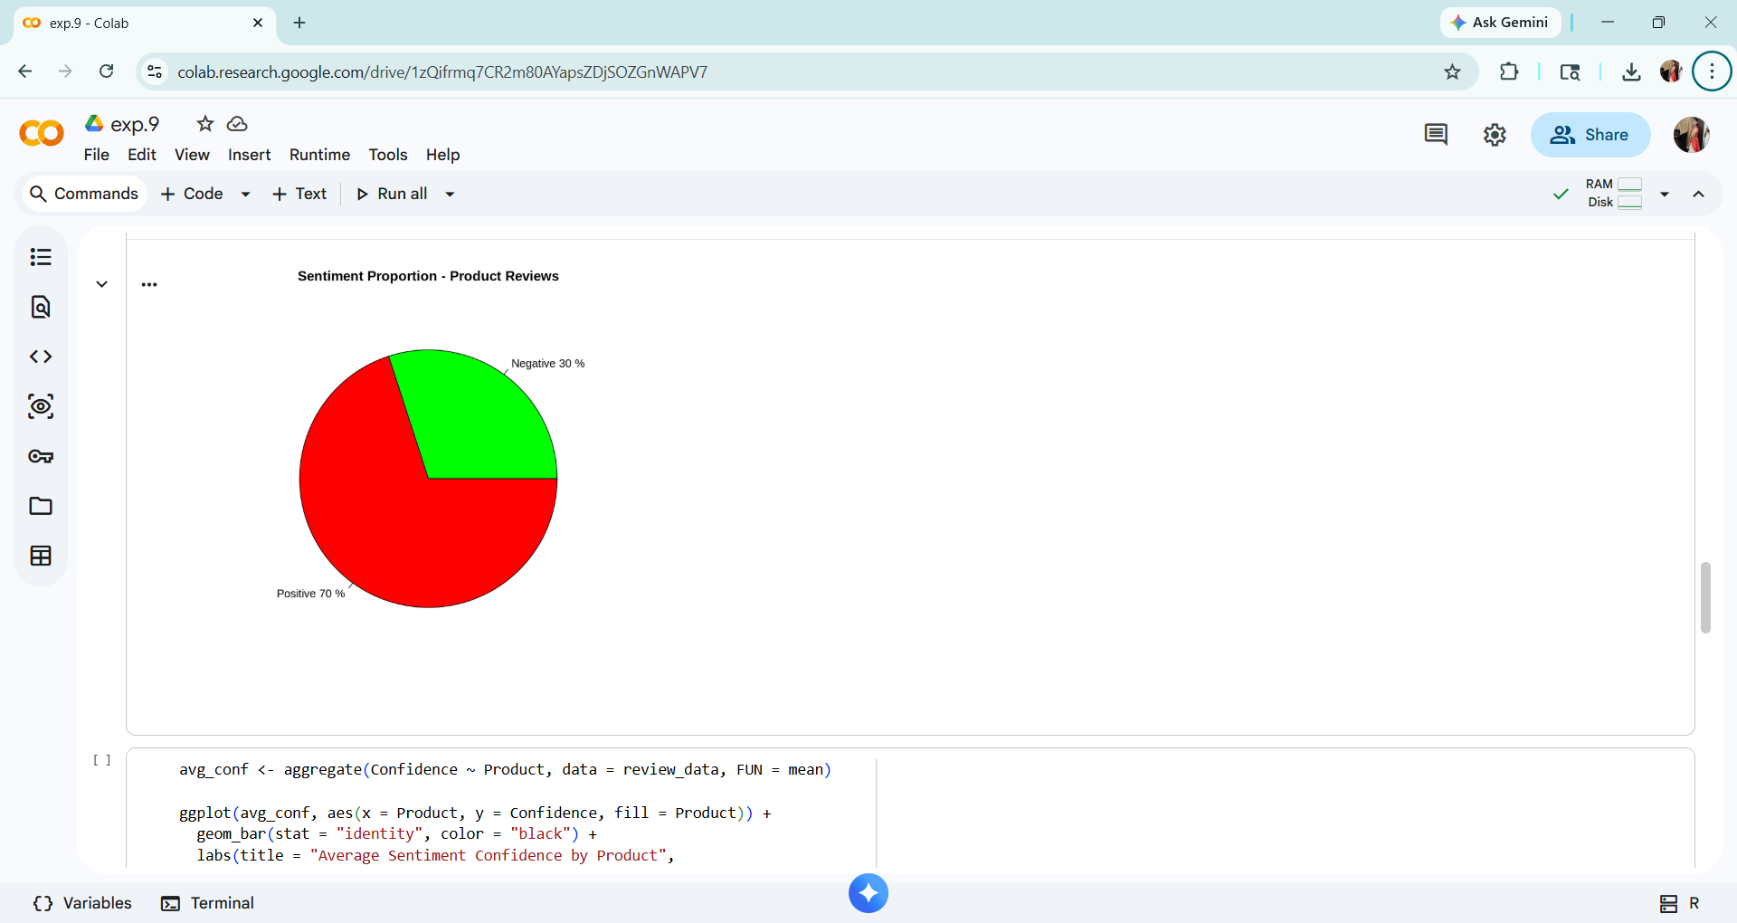
Cell 5 Output: Pie Chart – Sentiment Proportion
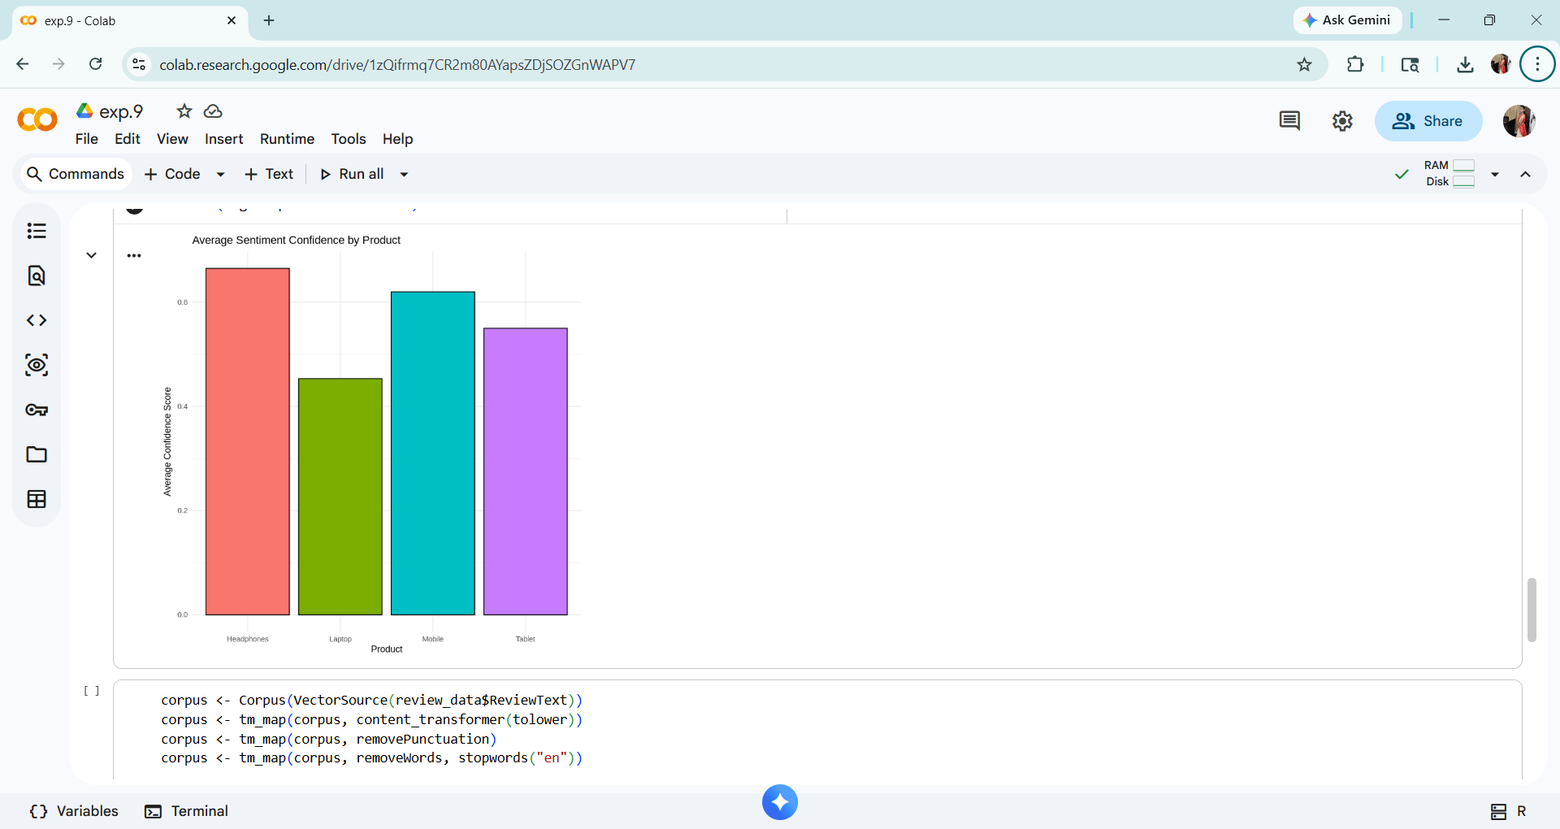
Cell 6 Output: Bar Chart – Avg Confidence Score by Product
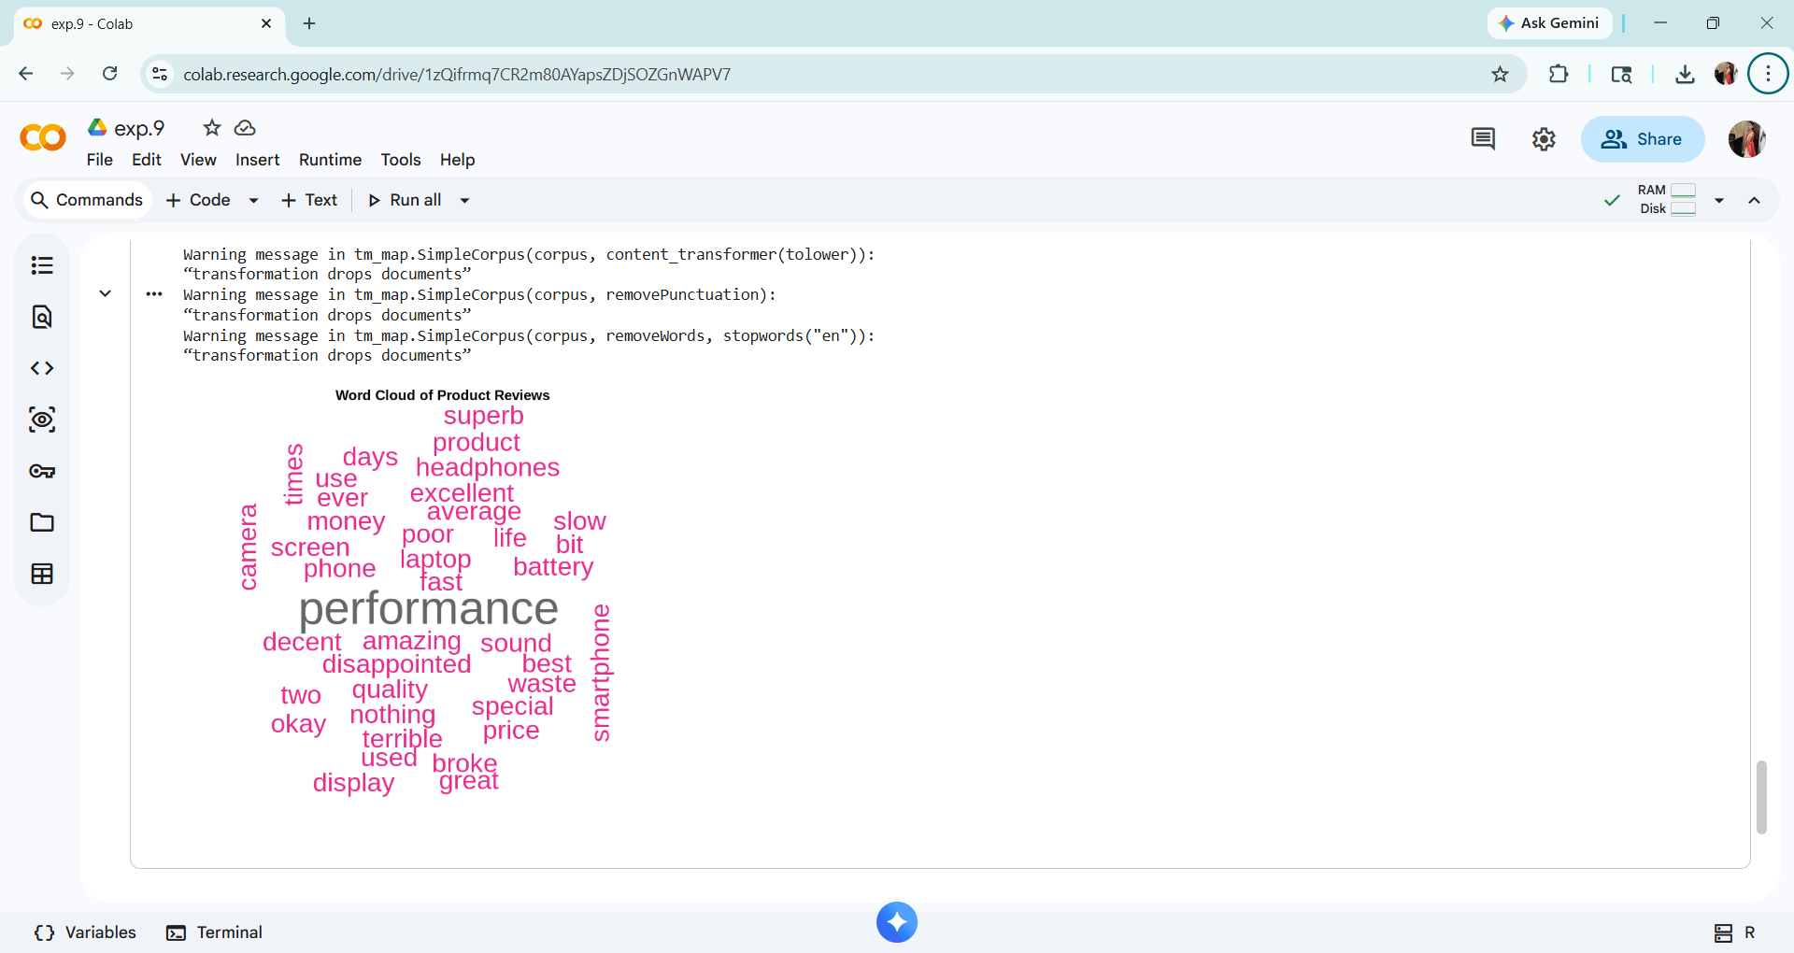
Cell 7 Output: Word Cloud – Most Frequent Words in Reviews

Output / Observation
- Bar Chart (Sentiment Distribution): Out of 10 reviews, 4 are Positive, 3 are Negative, and 3 are Neutral. Positive sentiment dominates, indicating overall moderate customer satisfaction.
- Pie Chart (Sentiment Proportion): Positive reviews account for 40% of total feedback, while Negative and Neutral reviews each constitute 30%, highlighting a mixed but slightly optimistic customer experience.
- Confidence Score Chart: Mobile phones receive the highest average confidence score, suggesting stronger and more polarized opinions from customers. Headphones and Tablets show moderate confidence levels.
- Word Cloud: Words like 'amazing', 'excellent', 'terrible', 'poor', and 'best' appear prominently, reflecting the emotional language used in product feedback.
- Overall Insight: Sentiment analysis using the syuzhet library in R effectively classifies product reviews. This approach can be scaled to thousands of reviews for real-time e-commerce feedback monitoring and product improvement.

Submitted By
Name : K . MADHU SREE
Reg No : 11249A170
CSE, II Year | Section S5
R-Programming Lab
SCSVMV UNIVERSITY

